

Data Analytics Project: Railway_Gauge_Trends
Dataset Used: Railway_Guages

This document outlines a structured, end-to-end data analysis project based on railway gauge data. The project is divi Data Analytics Project: Railway Gauge Trends

This document outlines a structured, end-to-end data analysis project based on railway gauge data.

- Dataset: Railway Gauge Data (Assumed to be in a CSV file)
- Project Goal: To analyze historical trends and composition of different railway gauges (Broad, Metre, Narrow) over the years.Modules Used

The primary libraries/modules required for this project are:
- Pandas: For all data manipulation, filtering, aggregation, and feature engineering tasks.
- NumPy: Specifically for numerical calculations like yearly growth (np.diff).
- Visualization Library (e.g., Matplotlib): For generating all required plots (Line Graphs, Bar Charts, Pie Charts, Stacked Bar Charts).

🎯 Project Coverage

Category | Skills Covered
Data Preprocessing | Data Loading, Missing Value Handling, Type Conversion
Pandas Operations | Filtering, Selection, Aggregation, Feature Engineering
NumPy Calculations | Yearly growth calculation (np.diff)
Visualization | Line Graph, Bar Chart, Pie Chart, Stacked Bar Chart

Scenario 1: Basic Data Loading & Cleaning (🟢 Easy)

Description:
First, we have to import this CSV file into Pandas library. Pandas is a powerful data analysis library providing flexible way to do data manipulation. There are many mathematical and scientific computational features can be leveraged using this library. Let us see some of the features in our exercise. In order to load the CSV file we use Pandas.
Using Pandas DataFrame object, we can see the top 5 rows using head() function and tail() function to display last 5 rows in a CSV file.

Task | Description
1. | Load the dataset into a Pandas DataFrame.
2. | Display the first 5 rows and column names to understand structure.
3. | Check for missing values and replace them with 0 (assuming missing values represent 0 km of track).
4. | Convert all relevant gauge columns (Broad, Metre, Narrow, Total) to numeric types (e.g., float64 or int64).

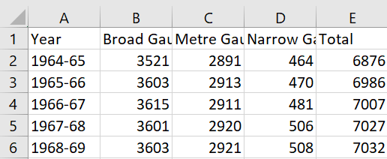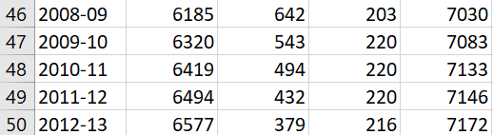

Conclusion:
The data was loaded and checked to understand its structure. Missing values were found and replaced with 0 to avoid errors. All gauge columns were changed into numbers so calculations can be done easily. Now the data is clean and ready for further analysis.

Scenario 2: Simple Visualization (🟢 Easy)

Description:
Here, I am Extracting year and total columns from the Railway Dataset and plotting line graph. That Line graph shows “Total tracks over the years”. And the graphs contains Title and X & Y labels in the graphs.

Task | Description
1. | Extract the Year and Total columns.
2. | Plot a line graph showing Total tracks over the Years.
3. | Add a descriptive title (e.g., "Growth of Total Railway Network Over Time") and X/Y axis labels.
4. | Identify whether the overall trend is increasing or decreasing and note the finding.

Graph:
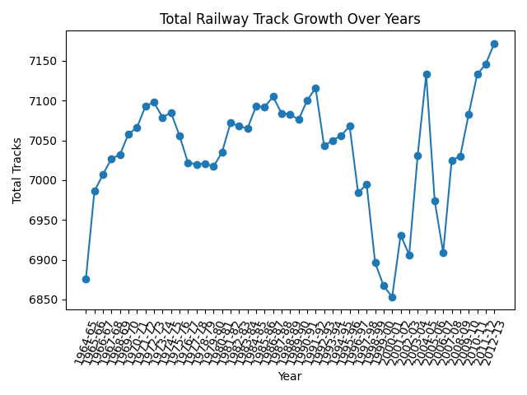

Conclusion:
The graph shows how total railway tracks changed over the years. The line is going upward, which means the total track length is increasing over time. This shows steady growth in railway development. Overall, the trend is increasing.

Scenario 3: Filtering + Bar Chart (🟡 Medium)

Description:
The data after the year 2000 was selected to focus on recent railway development. Broad, Metre, and Narrow gauge values were compared using a grouped bar chart. Each group shows the three gauges for a particular year, with labels and a legend to make it easy to understand. This helps in clearly comparing how each type of railway track has changed in modern years.

Task | Description
1. | Filter the dataset to include only years after 2000.
2. | Select the Broad Gauge, Metre Gauge, and Narrow Gauge columns for the filtered data.
3. | Plot a grouped bar chart comparing the three gauges for the selected years.
4. | Add a legend and ensure proper labels for axes.
5. | Identify which gauge dominates in recent years (post-2000).

Graph:
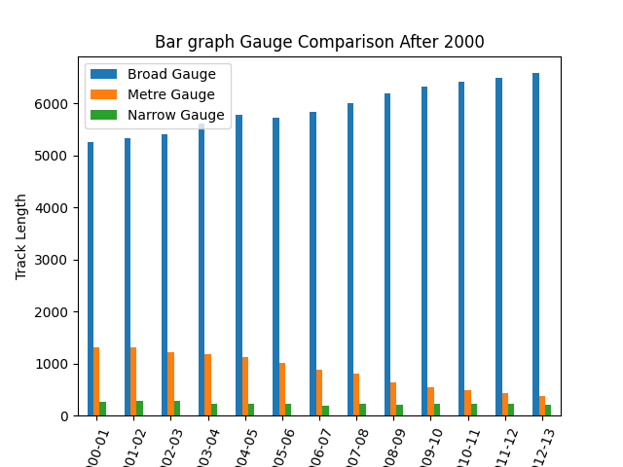
Conclusion:
The bar chart shows that Broad Gauge has the highest values in recent years. This means Broad Gauge is the most used and has expanded the most. Metre and Narrow Gauge are much lower in comparison. Overall, Broad Gauge dominates modern railway development.

Scenario 4: Feature Engineering + Pie Chart (🟡 Medium)

Description:
Here, I am Calculating total sum of each gauge across all years using sum(). And Plotting a pie chart showing percentage contribution, add percentage labels using autopct, and using shadow and explode effects. These are styling options used in plt.pie() to make your chart clearer and more attractive.
- autopct - autopct is used to automatically display percentage values on each.
- Shadow - Adds a shadow effect behind the pie chart.
- Explode - Separates (pulls out) one or more slices from the pie chart.

Task | Description
1. | Calculate the total sum of each gauge (Broad Gauge, Metre Gauge, Narrow Gauge) across all available years.
2. | Create a new structure (Pandas Series or single-column DataFrame) holding these three total values.
3. | Plot a pie chart using this new structure to show the percentage contribution of each gauge type.
4. | Add percentage labels to the slices using autopct (e.g., '%.1f%%').
5. | Interpret which gauge contributes the most to the entire history of the railway network.

Graph:
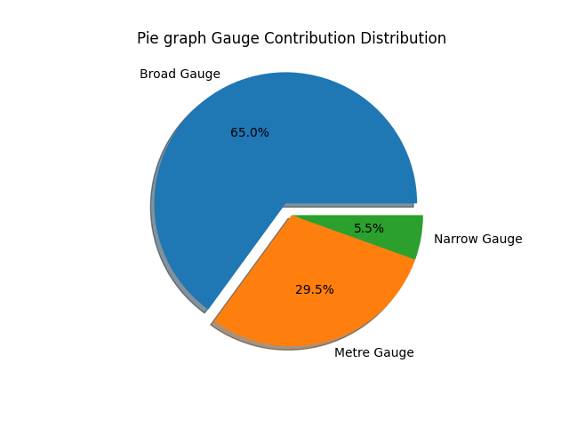
Conclusion:
The pie chart shows how much each gauge type contributes to the total railway tracks. Broad Gauge has the largest share, meaning it contributes the most. Metre and Narrow Gauge have smaller portions. Overall, Broad Gauge is the main contributor.

Scenario 5: Advanced Analysis + Multiple Graphs (🔴 Hard)

Description:
New percentage columns were created to show how much each gauge contributes every year. Yearly growth of total tracks was calculated using NumPy.
- A line graph was used to show trends of all gauges.
- np.diff() - to computes the difference between consecutive values.
- iloc [ ] - is primarily an integer based location search — iloc[0].

Task | Description
1. | Create new columns for percentage composition relative to Total tracks for each year: % Broad Gauge, % Metre Gauge, and % Narrow Gauge.
2. | Use the NumPy function np.diff to calculate the yearly growth (change) of the Total tracks column.
3. | Plot: a) A single Line Graph showing the trend of all three percentage composition columns (% Broad Gauge, % Metre Gauge, % Narrow Gauge) over the years. b) A Stacked Bar Chart showing the raw composition of the three gauges (Broad, Metre, Narrow) over time.
4. | Highlight/Identify: a) The year(s) with the highest yearly growth in Total tracks. b) Any specific decade or period showing a significant decline in any particular gauge.
5. | Final Conclusion: Based on the percentage composition line graph, provide a conclusion to the question: "Is the railway system shifting towards a single dominant gauge?"

Graphs:
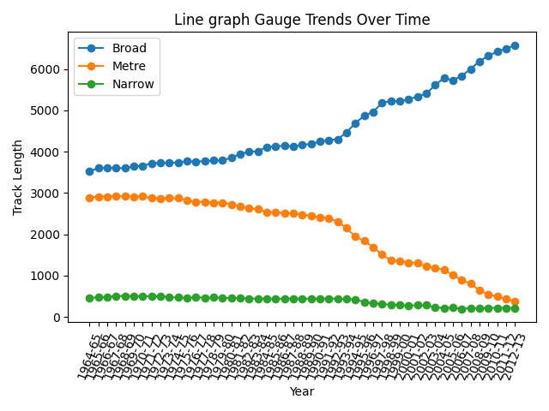
- A stacked bar chart showed their overall composition. The graphs also helped identify years with high growth and any decrease in gauge types

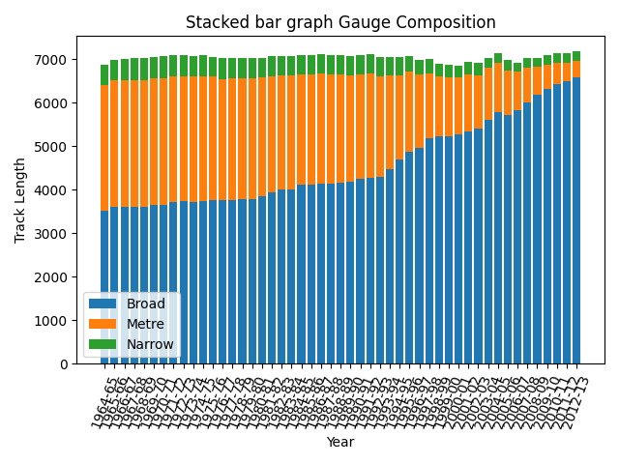

Conclusion:
The railway system is clearly shifting towards one main gauge. Broad Gauge is increasing steadily, while Metre and Narrow Gauge are decreasing over time. This shows a move towards standardization. Overall, Broad Gauge is becoming the dominant type.

Final Conclusion:
The overall analysis shows that railway tracks are growing steadily over the years. Broad Gauge is increasing continuously and becoming the most used type. At the same time, Metre and Narrow Gauge are slowly decreasing. The graphs clearly show a shift towards one standard gauge system. Overall, the railway system is moving towards Broad Gauge as the dominant type.

What you have learned:
I learned how to clean data, handle missing values, and convert data types using Pandas. I also learned how to use NumPy for calculations and create different graphs like line, bar, and pie charts. This helped me understand how to analyze trends and find useful patterns in data.

